**The documentation of the PCB module**

The PCB board consists of three separate modules: ADC module, ADXL335 accelerometer, ADXL203 accelerometer module. Below I explain every part separately.

**ADXL335 accelerometer**

Figure 1 represents the schematic of the ADXL335 accelerometer module. The name of the components are placed above the corresponding components for the sake of clarity.

Capacitors **C5, C6**, and **C10** function as low pass filters for X, Y, and Z-axis outputs of the accelerometer, respectively. The bandwidth of the outputs of the accelerometer can be adjusted by varying the value of these capacitors (Table 1).

**L** (top layer) - smd led that shows whether the power supply is connected to the module or not.

**R8** (bottom layer) - 1 kOm resistor. It is connected to the led serially limit the current. This name was not labeled in the PCB.

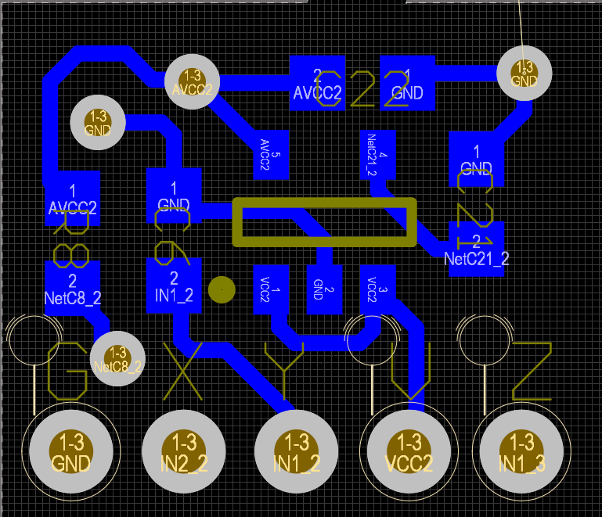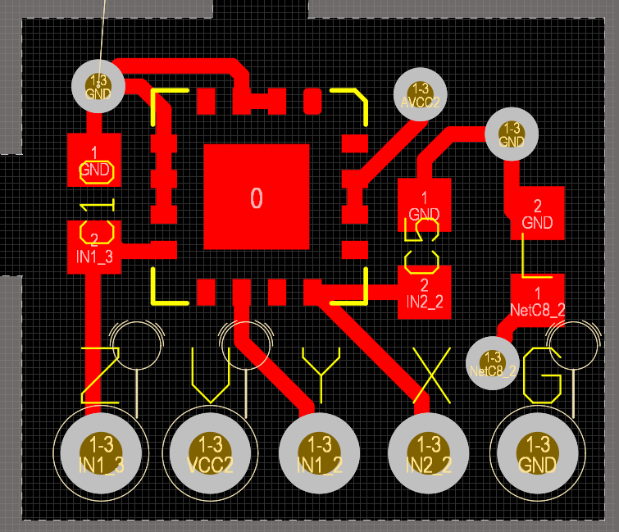

Figure 1. Top and bottom layer of ADXL335 accelerometer module.

Table 1. Filter Capacitor Selection.

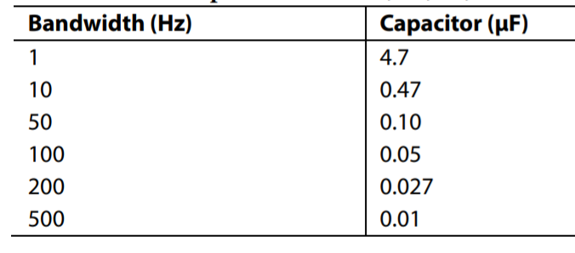

**C21**(bottom layer) -10 nF capacitor. It is connected to the voltage regulator.

**C22** (bottom layer) - capacitor in the range of 1-10 uF. It is connected to the voltage regulator.

The PCB also consists of the accelerometer chip ADXL335 (top layer) and the voltage regulator (bottom layer). The correct orientation of the accelerometer can be identified by looking at the rounded corner in the top overlay (yellow color). The first pin of the accelerometer has to be adjusted to this place.

**ADXL203 accelerometer**

Figure 1 represents the schematic of the ADXL335 accelerometer module. The name of the components are placed above the corresponding components for the sake of clarity.

Capacitors **C25** and **C26** function as low pass filters for X and Y-axis of the accelerometer, respectively. The bandwidth of the outputs of the accelerometer can be adjusted by varying the value of these capacitors (Table 2).

**L** (top layer) - smd led that shows whether the power supply is connected to the module or not.

**R12** (bottom layer) - 1 kOm resistor. It is connected to the led serially limit the current. This name was not labeled in the PCB.

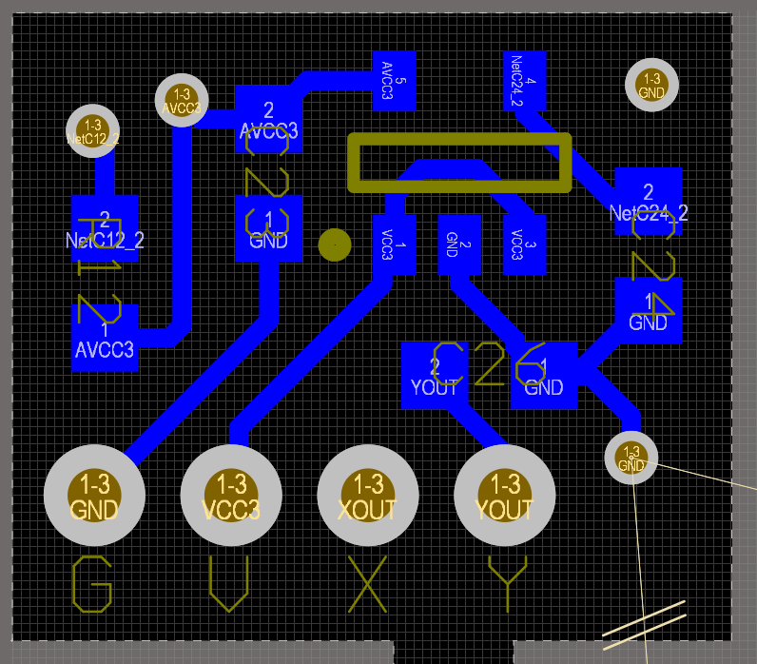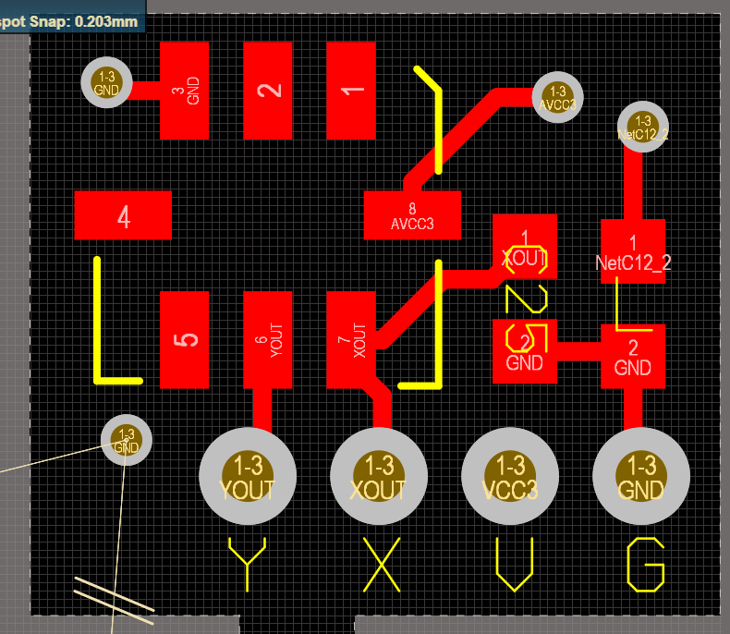

Figure 2. Top and bottom layer of ADXL203 accelerometer module.

Table 2. Filter Capacitor Selection.



**C24**(bottom layer) -10 nF capacitor. It is connected to the voltage regulator.

**C23** (bottom layer) - capacitor in the range of 1-10 uF. It is connected to the voltage regulator.

The PCB also consists of the accelerometer chip ADXL203 (top layer) and the voltage regulator (bottom layer). The correct orientation of the accelerometer can be identified by looking at the rounded corner in the top overlay (yellow color). The first pin of the accelerometer has to be adjusted to this place.

**ADC module**

The board incorporates two ADC chips (Analog Devices AD7685, check the [datasheet](https://www.analog.com/media/en/technical-documentation/data-sheets/AD7685.pdf)). It can sample two analog signals in the range of 0-3V at 16-bit precision. Below I will explain every part of the module separately.

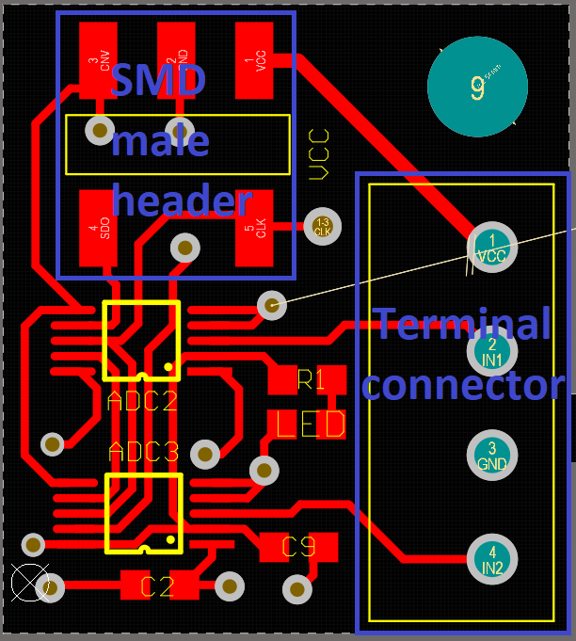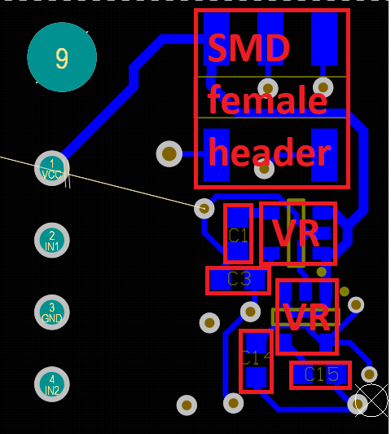

Figure 3. Top and bottom layer of the ADC module.

**Terminal Connector**

The terminal connector has four pins in the order of VCC, IN1, GND, IN2 (look at Figure 3). VCC can be used to power sensors, other modules, etc. IN1 and IN2 are input analog signals. GND is ground.

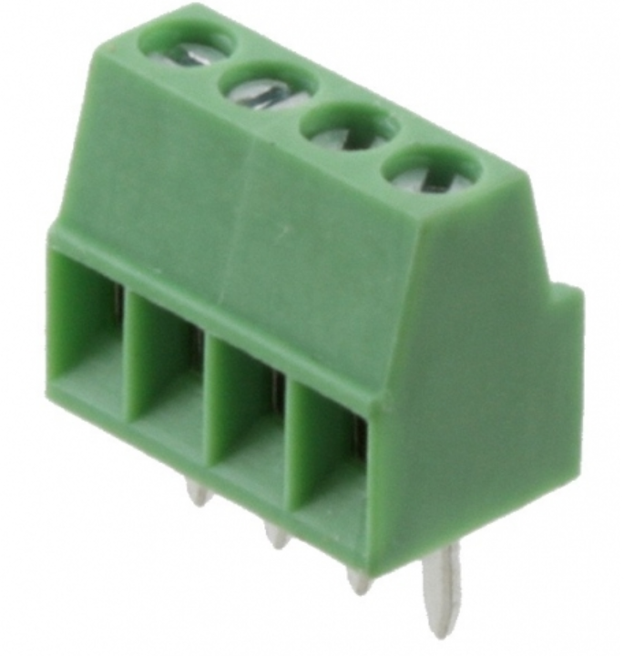

Figure 4. Terminal connector

**LED**(top layer) - smd led that shows whether the power supply is connected to the module or not.

**R1** (top layer) - 1 kOm resistor. It is connected to the led serially limit the current. This name was not labeled in the PCB.

**C9** (top layer) - capacitor in the range of 1-10 uf

**C2** (top layer) - capacitor in the range of 1-10 uf

**C1** (bottom layer) - 10 nf Capacitor

**C3** (bottom layer) - capacitor in the range of 1-10 uf

**C14** (bottom layer) - capacitor in the range of 1-10 uf

**C15** (bottom layer) - 10 nf Capacitor

**VR** (bottom layer) - LP2895 2.8-3V Texas Instruments voltage regulator

**ADC2, ADC3** (top layer)- AD7685 ADC chip. Look at the dot on the corner to solder this chip with proper orientation. 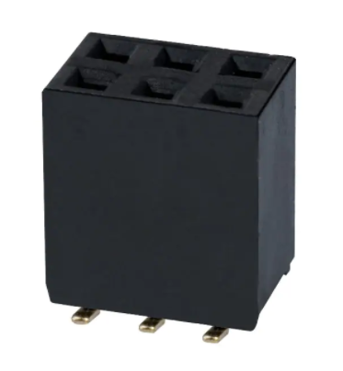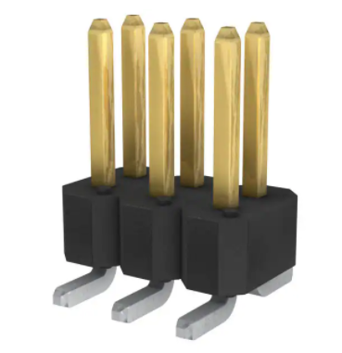

Figure 5. Female and male header connectors

The single board allows sampling two analog signals. However, several boards can be cascaded to sample more signals without increasing the number of wires that goes to a microcontroller. The cascading can be achieved by female (bottom) and male (top) header connectors.

When cascading, you need to connect the CNV and SDO pins to each other in the last board. The pins on the top layer of the first board are connected to the microcontroller.

**Connection to the microcontroller STM32F3**

CLK-PA5

SDO-PA6, PA4

CNV-PB1

GND-GND

VCC-5V